We’re going to go over some network cable layouts and diagrams and how they should be laid out when your constructing your own. There are three different layouts straight-through cables, crossover cables, and roll-over cables I’ll give a brief overview of each what there for and the differences. We’ll start with the straight-through lay out this is your most common layout used to connect computers printers and other periphery to routers, switches, and hubs. The layout is straight forward and simple a

One to one connection.

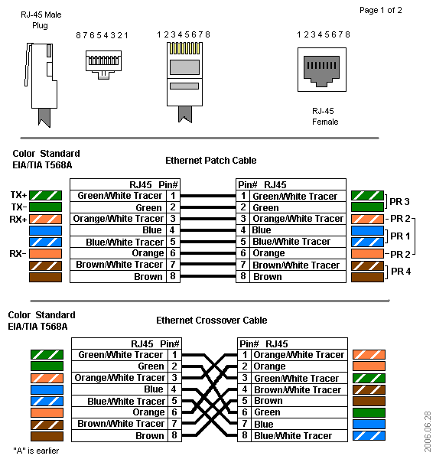

A crossover cable is a bit more complicated to put together as you can see form the image above. Crossover and straight-through cables are similar with the exception that the TX and RX lines are crossed and crossover cables were more often used to connect similar devices to each other switch to switch or router to router most devices now adays have auto sensing technology to detect cables devices and crosses pairs when needed.

Last up is the roll-over cable a mirror image in pinning also referred to as a Yost cable is more of a diagnostic cable its used to connect a devices console port to make programming changes. Yost cables are not really intended to carry data merely to create an interface with the device.

